

APEGGA extends special thanks to the 83 employers who supplied 6,846 salary statistics for its annual June survey of engineering, geological and geophysical positions.


Participating organizations provided salary information based on the level of responsibility of each employee's position, data on year of graduation, if available, and information on the type of organization. This year's survey also captured more salary data for master's and doctorate degrees and salary trends. A new category "Advanced Technologies" was added for the first time.

Additional information was again collected on other compensation provided to employees. The preliminary results are similar to those of last year with the data indicating that approximately 91% of the organizations provide a comprehensive benefits package which includes dental, drug, long-term disability, and medical plans. The average salary increase for all professions was 4.8%. More than 83% of the employers offer some type of retirement plan. Further information on other compensation will be made available through the 2001 Value of Professional Services booklet.

Selected highlights from this year's survey are given in the tables and figures that follow.

The complete results of the survey will be published in the 2001 Value of Professional Services booklet which will be available to members in November. Contact the Calgary or Edmonton APEGGA office to request a copy, or you can download off the APEGGA Web Site at www.apegga.org.

HOW TO USE SURVEY RESULTS

To use salary survey data as a guideline it is important to consider all reported results and to keep in mind the following remuneration concepts.

- Salary is basically determined by the level of responsibility of the position. (The Job Classification Guide should be used to determine your level of responsibility and the results reported in Tables 1-3 should be closely noted).

- Salary levels vary among industry sectors.

- Salaries by year of graduation (Figure 2) should only be used as a check on career progress relative to others of an equivalent age. Employers and members consistently want and use this information as a check on the more basic level-of-responsibility concept.

SURVEY NOTES

- The salaries quoted are BASE salaries in effect as of June 2001. The salaries include cost-of-living allowances and bonuses which have a continuing relationship to salary. Commissions, fringe benefits, profit sharing are not included.

- The statistical measures used in compiling the tables are the median, quartiles (Q3, Q1), deciles (D9, D1) and average. The median salary is the salary at which 50% of the respondent salaries are higher and 50% are lower. The Q3 salary is the salary at which 25% of the respondent salaries are higher and 75% are lower. The D9 salary has 10% of the salaries higher and 90% lower.

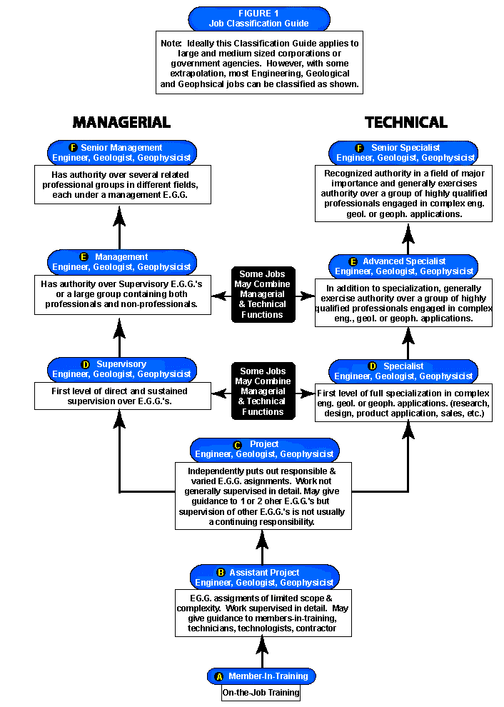

FIGURE 2

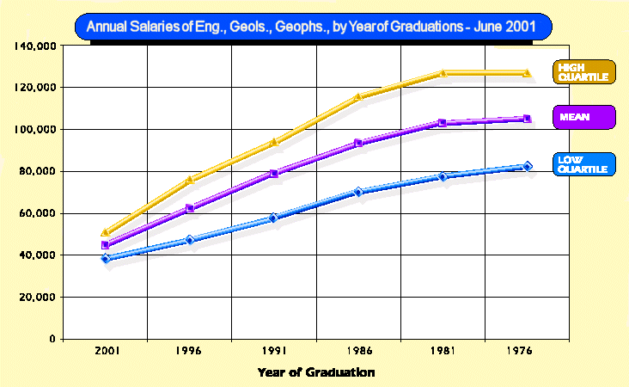
FIGURE 3

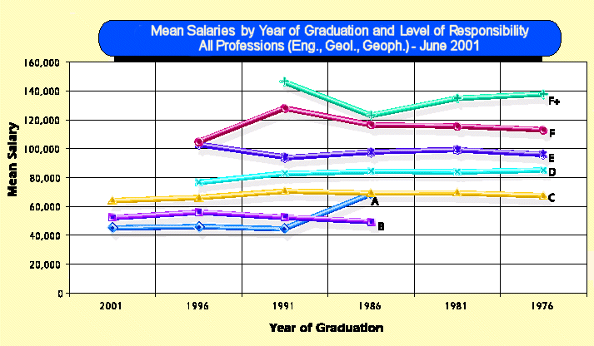
FIGURE 4
FIGURE 5

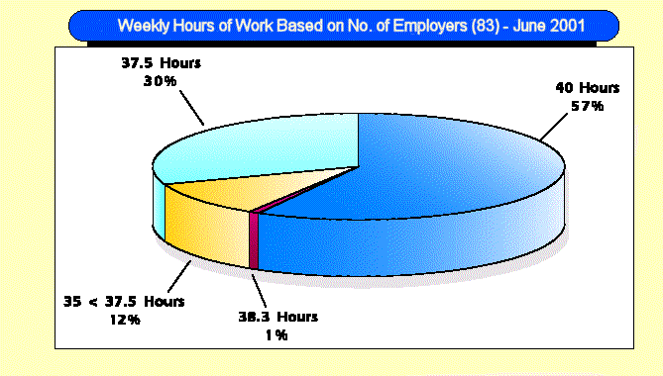

TABLE 1

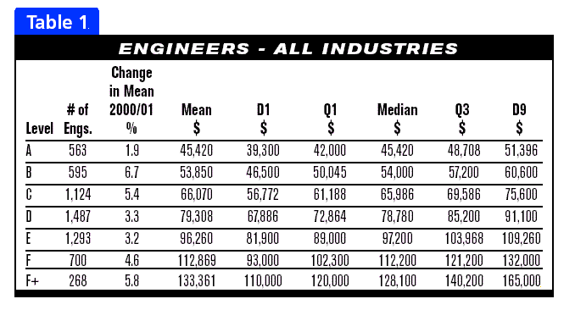
TABLE 2

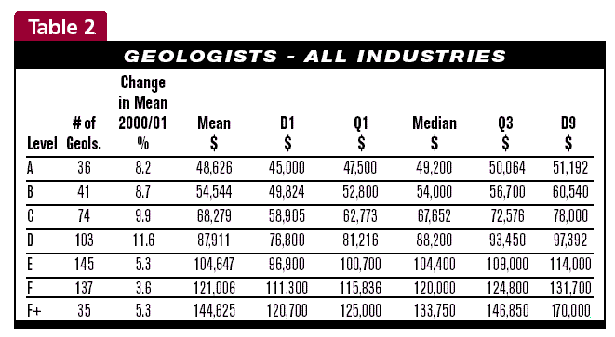

TABLE 3

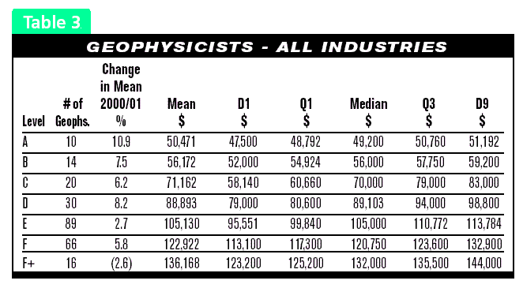
TABLE 4

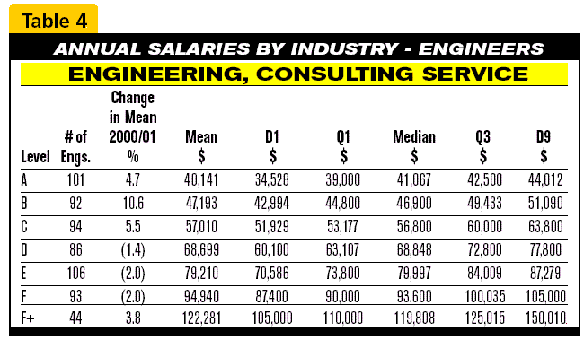

TABLE 4A

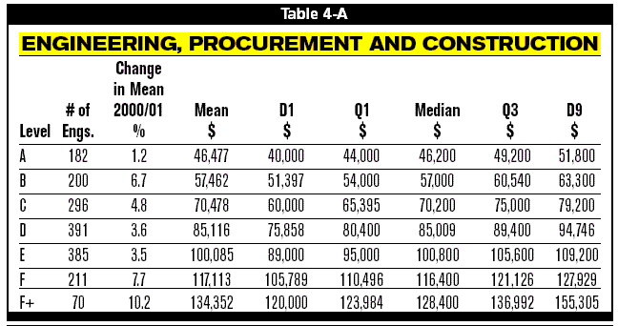
TABLE 4B

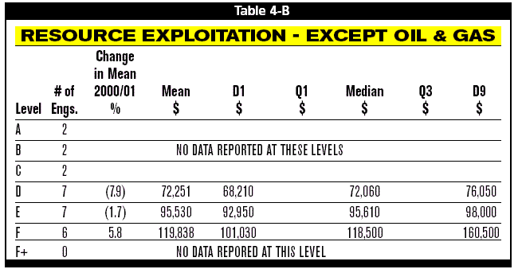

TABLE 4C

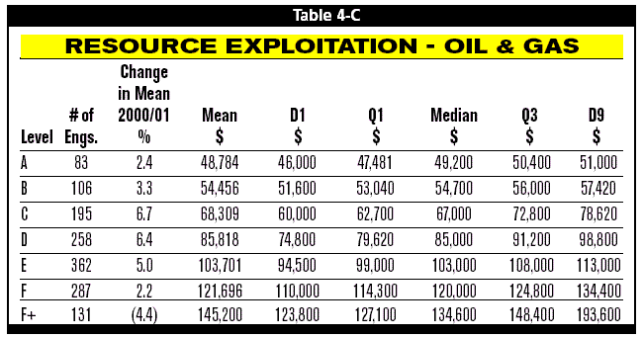
TABLE 4D

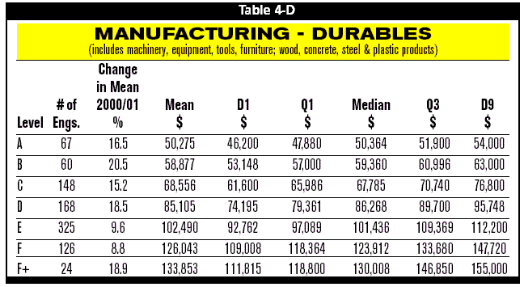

TABLE 4E

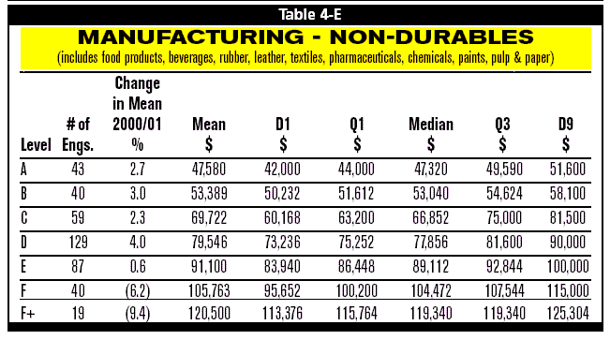
TABLE 4F

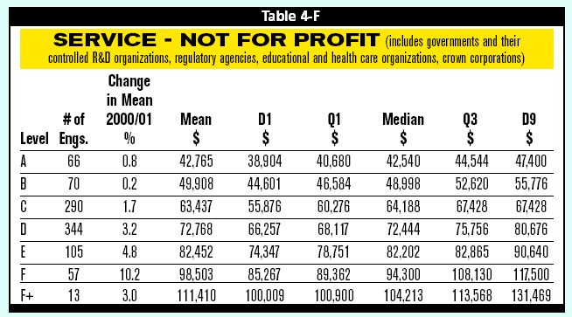

TABLE 4G

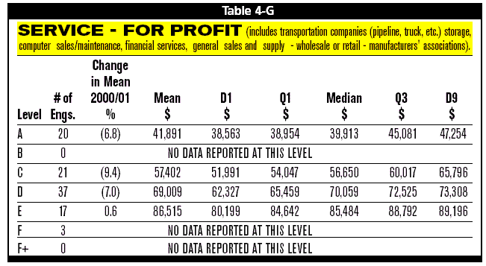
TABLE 4H

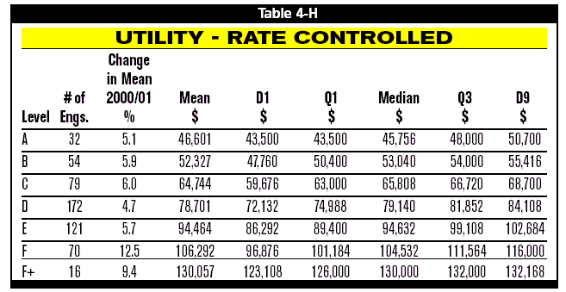

TABLE 4I

